**JavaScript Objects**

Q.1

<!DOCTYPE html>

<html>

<head>

    <title>JSO Q1</title>

</head>

<body>

    <script>

        class Rectangle {

            constructor(height, width) {

                this.height = height;

                this.width = width;

            }

        }

        const obj = new Rectangle(3, 5);

        document.write("The height of rectangle is: " + obj.height + " cm" + "<br>");

        document.write("The width of rectangle is: " + obj.width + "cm");

    </script>

</body>

</html>

Output:

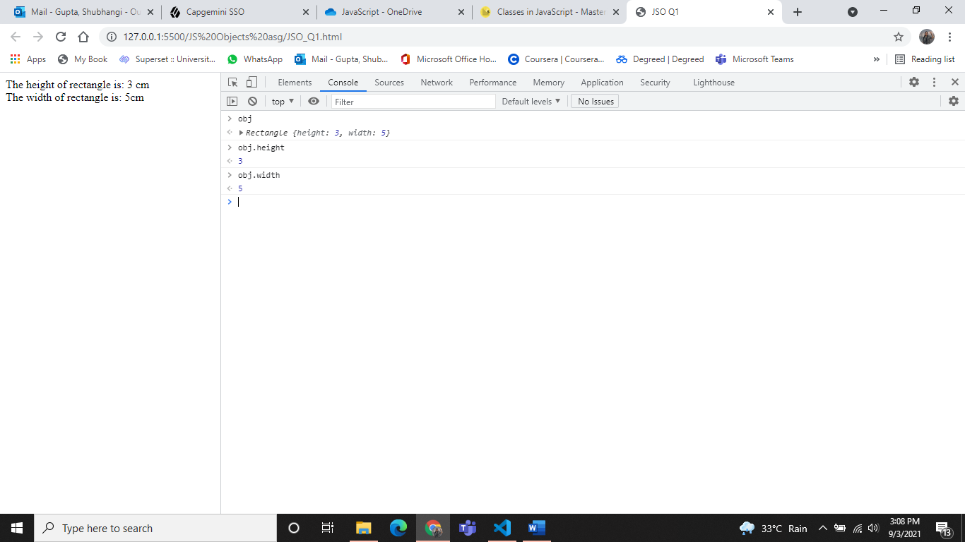

Q.2

<!DOCTYPE html>

<html>

<head>

    <title>JSO Q2</title>

</head>

<body>

    <script>

        class Rectangle {

            constructor(height, width) {

                this.height = height;

                this.width = width;

            }

            get area() {

                return this.height * this.width;

            }

        }

        const obj = new Rectangle(3, 5);

        obj.area;

        document.write("The height of rectangle is: " + obj.height + " cm" + "<br>");

        document.write("The width of rectangle is: " + obj.width + "cm" + "<br>");

        document.write("The area of rectangle is: " + obj.area + " sq.cm");

    </script>

</body>

</html>

Output:

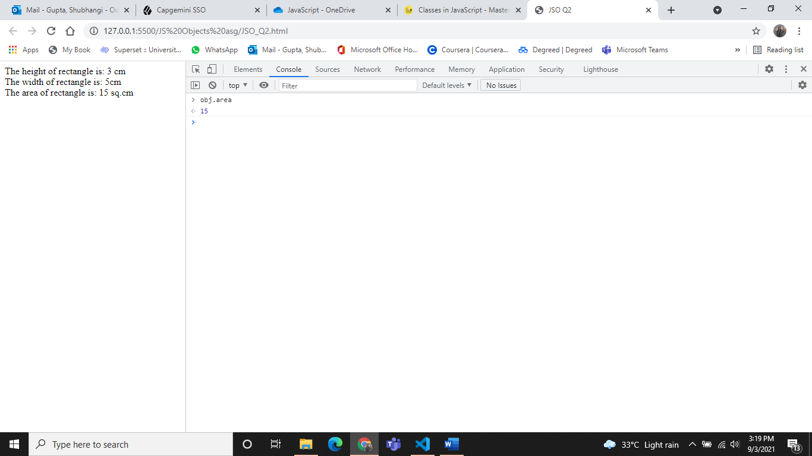

Q.3

<!DOCTYPE html>

<html>

<head>

    <title>JSO Q3</title>

</head>

<body>

    <script>

        class Rectangle {

            constructor(height, width) {

                this.height = height;

                this.width = width;

            }

            get area() {

                return this.height * this.width;

            }

        }

        const r = new Rectangle(4, 5);

        r.height = 50;

        //r.getarea();

        document.write("The height of rectangle is: " + r.height + " cm" + "<br>");

        document.write("The width of rectangle is: " + r.width + "cm" + "<br>");

        document.write("The area of rectangle is: " + r.area + " sq.cm");

    </script>

</body>

</html>

Output:

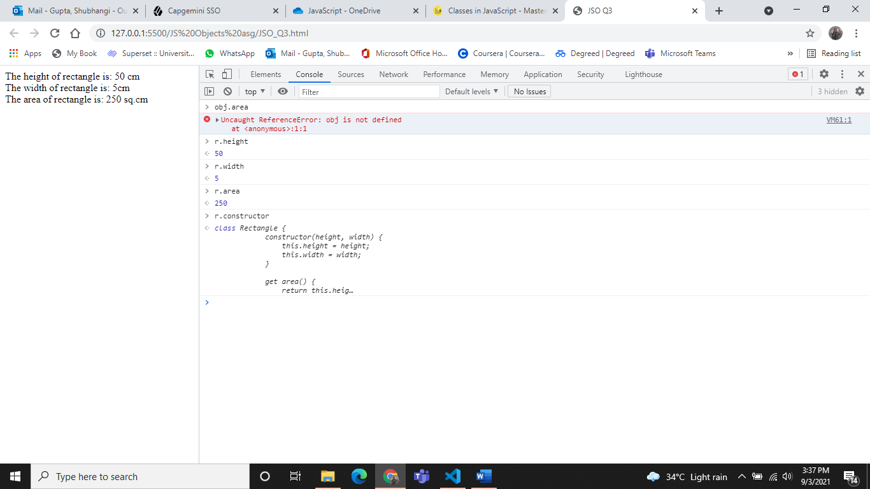

Q.4

<!DOCTYPE html>

<html>

<head>

    <title>JSO Q4</title>

</head>

<body>

    <p id="demo"></p>

    <script>

        let fname = "Shubhangi";

        let lname = "Gupta";

        document.getElementById("demo").innerHTML = fname + " " + lname;

    </script>

</body>

</html>

Output:

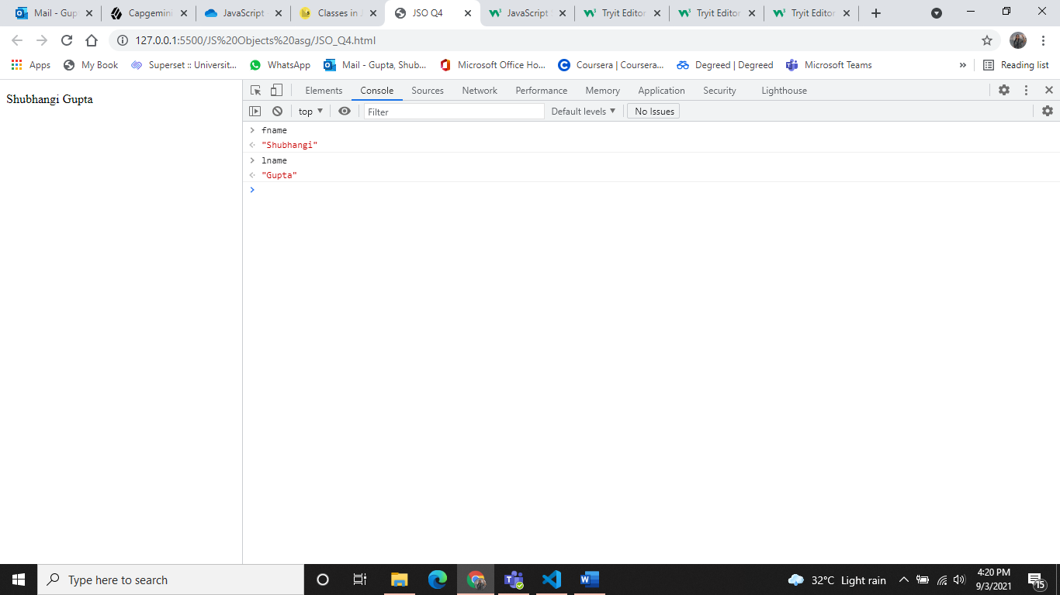

Q.5

<!DOCTYPE html>

<html>

<head>

    <title>JSO Q5</title>

</head>

<body>

    <p id="demo"></p>

    <script>

        let fname = "Shubhangi";

        let lname = "Gupta";

        let mname = "Jaiprakash";

        document.getElementById("demo").innerHTML = fname + " " + mname + " " + lname;

    </script>

</body>

</html>

Output:

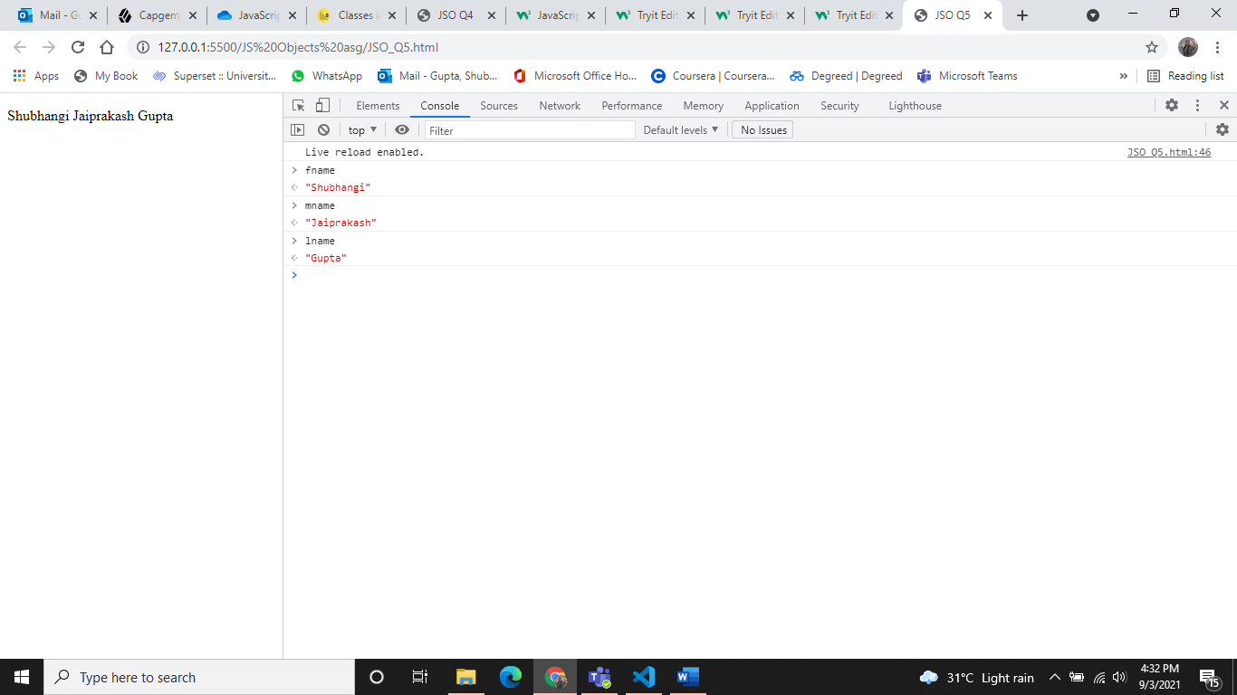

Q.6

<!DOCTYPE html>

<html>

<head>

    <title>JSO Q6</title>

</head>

<body>

    <script>

        var str = '({"fname" : "SHUBHANGI", "lname" : "GUPTA"})';

        var obj = eval(str);

        document.write(obj.fname + " " + obj.lname);

        console.log();

    </script>

</body>

</html>

Output:

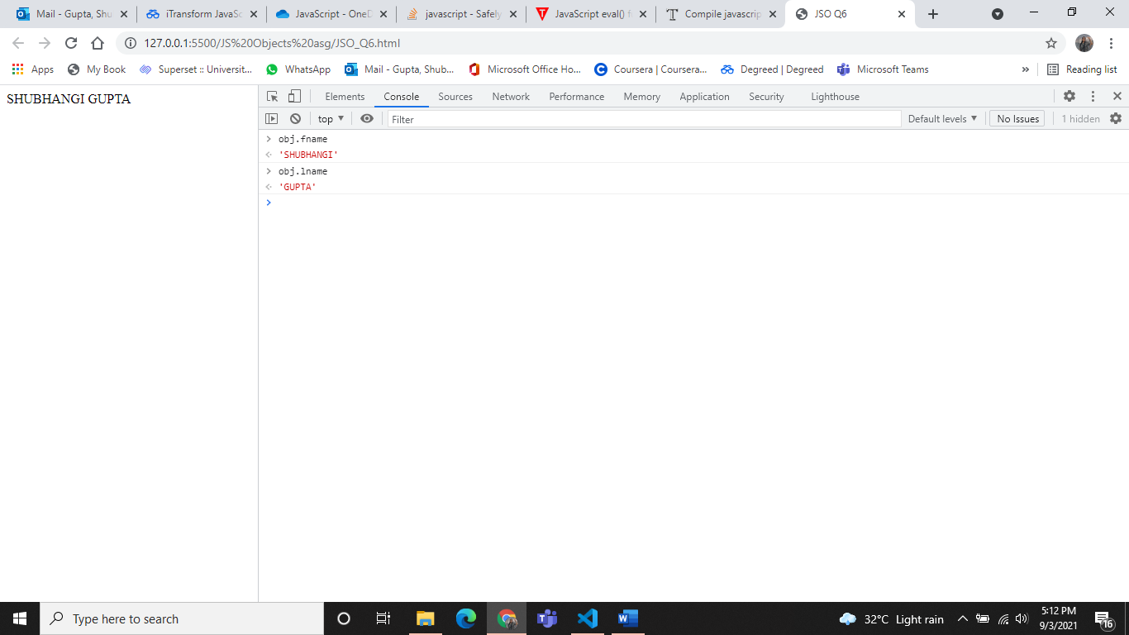

Q.7

<!DOCTYPE html>

<html>

<head>

    <title>JSO Q7</title>

</head>

<body>

    <script>

        var jsontext = '{"fname":"Shubhangi","lname":"Gupta"}';

        var obj = JSON.parse(jsontext);

        document.write(obj.fname + " " + obj.lname);

        console.log();

    </script>

</body>

</html>

Output:

